**Code:**clear all; close all;load('hw9p3_data.mat')r = cov(X');  
k = 1; y = zeros(6);

s(:,:,k) = eye(6,6);

while (k < 20000)

d = -inv(s(:,:,k)) + r; %tolerance value not sure...

if (max(abs(d)) < (10^-4))

break

end

a = 1;

y = s(:,:,k) - a*(d);

y(1:2,4:6) = 0; y(3,5) = 0; y(3,6) = 0; y(4,1) = 0; y(4,2) = 0; y(5:6,1:3)= 0;

s(:,:,k+1) = y;

while (min(eig(s(:,:,k+1)) <= 0))

a = a/2;

y = s(:,:,k) - a*(d);

y(1:2,4:6) = 0; y(3,5) = 0; y(3,6) = 0; y(4,1) = 0; y(4,2) = 0; y(5:6,1:3)= 0;

s(:,:,k+1) = y;

if a < 10^-6

break

end

end

k = k+1;

end

wcr = inv(s(:,:,k-1));

Covariance with Constraints.

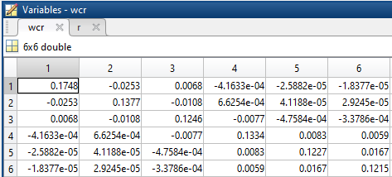

Covariance without Constraints.

